**UPCOMING EVENTS**

**Friday, 8th March 1st & 2nd Class swimming**

**from 9am - 9:45am**

**Monday, 18th March Bank Holiday - School closed**

**Tuesday, 19th March School closed**

**Wednesday, 20th March Curriculum Day - School closed**



**Thursday, 21st March School Re-opens @ 8:50 sharp**

**WELL DONE**

To the School Debating team, **Eoghan Birchall, Cadhla Cotter, Izza May Soliven, Hayley Earls, Erin Haynes and Shauna Byrne,** who travelled to Cloughleigh for the first round of the Inter Schools debating competition. They narrowly missed out on progressing to the next round!

**Lauren McCoy** who travelled to Edinburgh to represent her dancing school in The City of Birmingham Championships.

To the children of **2nd class** who received their First Confession on February 19th.

**Clothing Appeal**

Please support our ongoing appeal as funding for our school is

important in these very difficult times. All bags of clothing can be

dropped into the school throughout the year, during school hours.

**Karate Classes**

Karate classes are starting in the school hall on Tuesday, March 5th. Please take note of details on our Parents Noticeboard.

**Parents Association**

**Huge thank you** to the **Parents Association** on the recent Valentines Bake Sale fundraiser. Special word of thanks to **Edel O’Shaughnessy** for the amazing Love Bug cake which was won by Lorraine Nolan.

The Parents Association welcomes your support and participation at any stage. Next PA meeting – **11th March at 4pm**

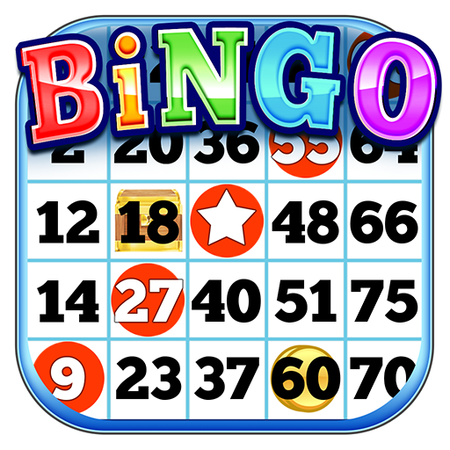

**Bingo**

Bingo continues on **Thursday, 7th March** in **Wolfe Tones GAA Club, Shannon at 8:00p.m.** Your continued support would be greatly appreciated. Children attending must be under strict parental supervision.

**Hip Hop & Zumba Classes**

Hip Hop continues for children every **Thursday from 4:15pm – 5:15pm**

**for 5 – 12 yr. olds.**

**School Records**

In accordance with the Department of Education it is the schools policy to

have **up-to-date contact details for each child** on file. Please advise the

school of **changes to contact numbers or addresses** at any stage during

the school year.

**Uniform**

Full School Uniform **MUST** be worn by all children on **Mondays, Wednesdays and Thursdays**. **Full School Tracksuit** on **Tuesdays and Fridays only.** **Please ensure that your child wears a school tie as part of their Uniform on Monday, Wednesday and Thursday. Grey socks and/or grey tights with black shoes only.**

Note: not wearing full school uniform is in breach of school discipline and also unfair to all the children who comply with ruling. Repeated breach of ruling – parents will be called to bring in full uniform.

**School Attendance**

School attendance is of utmost importance to everybody in St. Senan’s. Every school must comply with the legislation as set out in Education Welfare Act. **As parents you are required to complete an absence note in the event of your child being absent from school.** All such notes are filed in the school. When a child is absent for 20 days the school is, by law, required to notify the Education Welfare Officer. We welcome your co-operation in this regard.

**School Website**

Our school website address [www.stsenans.weebly.com](http://www.stsenans.weebly.com). In it you will find all up to date information **about our school** and our **monthly newsletter** so please do check in.

**Choir**

We will take a break from choir for a few weeks and resume after the St.Patrick’s Day Bank Holiday. A huge thank you to all of those children who sang for the First Confession mass.

**Afterschool Homework Club**

Afterschool Homework Club continues from **2:30 to 3:20 Monday to**

**Thursday.** **Cost is €10 per child per week/or €3 per day.**

**SCHOOL ACTIVITIES**

**School League**

The Indoor school League **FINAL**: **CLARE VS KILKENNY, lunchtime Friday, 1st March. Congratulations on reaching the final and well done to all those who took part in this year's Winter League!**

**Swimming**

Swimming will start for **1st and 2nd class** on **Friday 8th March** from **9am to 9:45am** in the Shannon Leisure Centre, for 5 sessions(final session on Friday 5th April).



**REMINDERS**

**Enrolment September 2019**

Please encourage all new entrants to **submit an enrolment form**

**immediately**. This can be downloaded from school website or obtained

from school office.



**Environmental Awareness**

St. Senan’s N.S. has long being associated with **Green Schools Project.**

In an effort to maintain our status:

* **Plastic bottles are NOT ALLOWED**. Recyclable drink bottles are only permitted. This is in keeping with departmental directive.
* Children **bring home all lunch wrappings**. We must minimise the use of plastic, tinfoil and clingfilm.
* Treats are permitted **ONLY ON FRIDAYS!**

This is in keeping with our Healthy Lunch Policy and is for overall health of the children. Please refer to the school website to view our **Healthy Eating Policy.**