St. Senan’s National School

Whole School Plan

Literacy

Introductory Statement
This whole school plan for English was initially formulated in consultation with teaching staff in St. Senan’s National School in term 1 of the 2021/2022 school year and revised in term 1 of the 2023/2024 school year. In St. Senan's we are clearly aware of the varying abilities and strengths of every child who enrols in our school.
Rationale
We prioritised this area of the curriculum because of the increasing importance placed on literacy because of the National Literacy and Numeracy Strategy 2011-2020. We also prioritised this curriculum area in light of the implementation of the new Primary Language Curriculum which came on stream in September 2016 and was revised in September 2019. Staff have engaged in training days based on the new Primary Language Curriculum and will continue to engage in these.
We believe that a consistent, structured and intensive oral language, phonological awareness and phonics programme will improve learning and teaching in all areas of the curriculum. Therefore we use the pdst manuals along with the Heggerty and UFLI programme to enhance the competence and confidence in phonics and blending, which will enable development in reading and writing. A thematic approach is used to teach Oral language, Reading and Writing. To further develop English comprehension we are using the Building Bridges of Understanding programme and to develop written English we study writing genres on a monthly/6wk block using ‘A Structured Approach to Writing genres’
Vision
It is our vision to create a school where our pupils will communicate, read and write with and for each other, staff, parents/carers, visitors and the wider school community with clarity, confidence, fluency and respect.
Aims
We aim, through this plan, drawn up in accordance with the Primary Language Curriculum, to set out our approach to language teaching. This plan will form the basis for teachers’ long and short-term planning. It will also inform new teachers of the approaches and methodologies used in our school.
We endorse the aims of the New Primary Language Curriculum, which are presented in 3 groups. The Primary Language Curriculum, and this whole-school plan, aims to support teachers to:
- Children and their Lives
  - enable children to build on prior knowledge and experience of language and language learning to enhance their language learning
  - encourage children of different languages and cultures to be proud of and share their heritage
  - recognise the wide variation in experience, ability and language style which children bring to language learning in school as a first step in enabling them to engage in relevant and meaningful communicative relationships.

- Children’s communications and connections with others
  - embrace children’s uniqueness by nurturing their appreciation of their home language, their understanding of language and diversity, and their ability to use different languages, gestures and tools to communicate with people in a variety of contexts and situations.
  - encourage and enable children to communicate effectively in both the first and second language of the school and to communicate in their heritage language for a variety of purposes.
  - enable children to fully engage with and enjoy a wide range of relevant and meaningful linguistic and communicative experiences with peers and adults.

- Children’s language learning and development
  - promote a positive disposition towards communication and language by fostering within children a lifelong interest in and a love of language learning for personal enjoyment and enrichment
  - broaden children’s understanding of the world through a rich variety of language experiences and through fostering an awareness and appreciation of other languages and cultures in an enriching learning environment
  - encourage children to engage personally with and think critically about a broad range of spoken, gesticulated, written and multimodal texts
  - support children to develop their literacy skills and enable them to progress at their own learning pace in oral language, reading and writing
  - nurture within children an awareness of language, allowing them to appreciate and understand the content and structure of languages and acquire a basic understanding of the history of languages and other cultures
Curriculum Planning

Strands and Elements
The following table sets out the Strands and Elements of the Primary Language Curriculum:

Element 1: Communicating

Strand: | Learning Outcome:
Oral Language | Engagement, listening and attention (intentionality, verbal memory)  Social conventions and awareness of others (relevance, turn- taking, extra- and paralinguistic skills)
Reading | Engagement (intentionality) Motivation and choice (relevance)
Writing | Engagement (intentionality)  Motivation and choice (relevance, purpose, audience)

Element 2: Understanding

Strand: | Learning Outcome:
Oral Language | Sentence structure and grammar (syntax, morphology) Acquisition and use of oral vocabulary (semantics, verbal memory, articulation skills)  Demonstration of understanding (semantics)
Reading | Conventions of print (meaning and understanding of text/illustration)  Phonological and phonemic awareness  Phonics and word recognition (alphabetic principle, word identification strategies)  Reading vocabulary (semantics)
Writing | Conventions of print and sentence structure (syntax) Spelling  Vocabulary (semantics)

Element 3: Exploring and using

Strand: | Learning Outcome:
Oral Language | Requests and questions Categorisation  Retelling and elaborating (narrative text and response)

Playful and creative use of language (aesthetic dimension of language)
Information giving, explanation and justification (expository text)
Description, prediction and reflection
Reading | Purpose, genre and voice (awareness of author’s purpose) Comprehension (comprehension, text organisational structure and fix-up strategies)  Fluency and self-correction (accuracy, fluency and meaning)
Writing | Purpose, genre and voice (sense of voice, aesthetic dimension of text)  Writing process (using processes, structures and language register)  Response and author’s intent (author’s purpose and  responding) Handwriting (legibility)

Approaches in our School
1. Oral Language
Learning Outcomes for Oral Language
● See Page 22 of the Primary Language Curriculum
Whole School Strategies for Oral Language
▪ Assemblies:
Regular whole school/year group assemblies
Appropriate and respectful language is modelled
Good listening and appropriate responses are encouraged
Common social functions are taught
Positive non-verbal behaviour is encouraged
▪ Yard:
Using words to communicate and solve problems
Use of Incredible Years language
Self-Maintaining Language
Model positive and respectful language
Use of Restorative Practice Questions
▪ Aistear:
Aistear activities daily in Junior,Senior Infants , (1st) classes. We use a thematic approach for Aistear and ensure that an oral language/role play station is included in Aistear theme.

Timetable for Oral Language
▪ Aistear: 45 minutes 3/4 days week (at the discretion of class grouping)
▪ Oral language lessons daily: discreet lessons/formal lessons/informal language use
Some Activities/Methodologies currently used for Oral Language The following skills will be modelled and taught in our school at all class levels:
▪ Using words for common social functions in a polite and respectful manner (on going, daily)
▪ Communicating to meet personal needs (on-going, daily)
▪ Listening (rhymes, jingles, riddles, listening activities, bingo, news)
▪ Recalling (re-telling stories, class trips/visits, news)
▪ Naming (name, address, days, months, seasons, family members, things you need for/find in)
▪ Categorising and classifying (people, places, family, clothes, weather, animals, food, pets)
▪ Describing (colour, shape, feelings, characters)
▪ Denoting Position (orientation-left/right, relational-under/beside/behind/on/in) ▪ Sequencing (alphabet, days, months, seasons, times of day, sequencing words) ▪ Reasoning (relational words-because/but, problem solving-what shall I do? 20 questions, proverbs)
▪ Giving instructions and directions (how do we make a cup of tea/go to the shop?) ▪ Reporting (reporting back from a group activity or project)
▪ Speaking out clearly (on going, daily)
▪ Predicting (hear part of a story, what do you think will happen next?, picture sequences)
▪ Projecting/empathising (picture/story, How do you think they are feeling? How would you feel if I?)
▪ Imagining (a new planet, a newly discovered species of animal)
▪ Questioning (20 questions, the Yes/No game show)
▪ Interpreting and using appropriate non-verbal language
▪ Taking turns in speaking and listening (circle-time, news time)
▪ Showing tolerance for views of others (circle-time, debating)

Resources/Methodologies for Oral Language
- See each class level
- Aistear
- Five Components of Effective Oral language Instruction booklet PDST
- SESS Functional Language Levels 1 - 8
https://www.sess.ie/resources/sess-functional-language-and-communication-resource
- Over The Moon
- Conversation Station
- Games - Would you Rather,Headbandz, 30 seconds, barrier games, don’t say it
- Word walls in each classroom
Teacher’s planning for Oral Language
● English oral language and Gaeilge ó bhéal are integrated thematically where possible, through teaching topics at the same time, discussing language based on stories
● New vocabulary is displayed in the classrooms. Aistear words are displayed with pictorial clues (Infant classes) and working Word Walls are displayed from Junior Infants upwards.
● Key vocabulary for pupils is identified for all subject areas and listed in teachers’ short-term planning.
- Just as in Gaeilge where nathanna cainte and feidhmeanna teanga are taught so too are functional elements of language eg- social interaction, conversation, opinions and information. Teachers look at the level pertaining to their class
e.g Level 1 - Junior Infants with relevant teacher planning, checklist and guide.
A key vocabulary guide is provided in the following ten areas
- · Myself
- · My Family
- · My House
- · School
- · Food
- · Television
- · Shopping
- · Pastimes
- · Clothes
- · Weather

*See sample checklist for Level 1 below

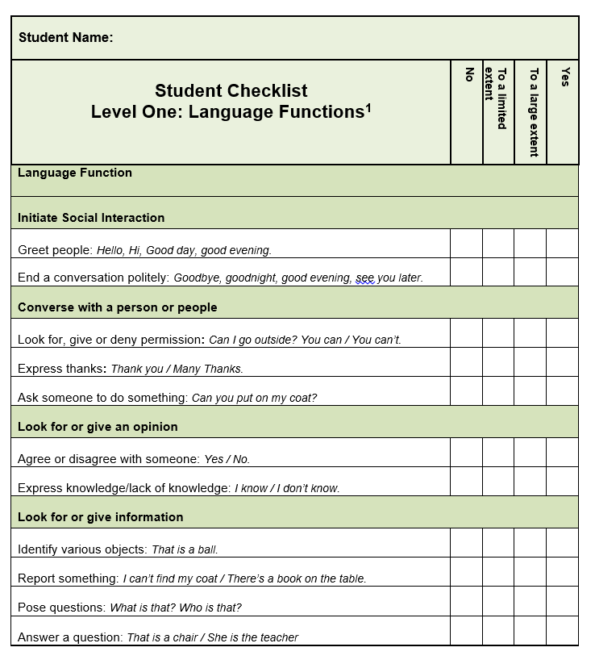

Whole School Approach to Oral Language
Junior/Senior Infants
Term | Oral Language Topics  Junior Senior
Term 1 | - Recount  - Partner and small groups  - Conversations | - Recount  - Partner and small groups  - Conversations
Term 2 | - Giving Instructions | - Giving Instructions
Term 3 | - Revision and all of the above | - Revision and all of the above

First/Second Classes
Term | Oral Language Topics  First Second
Term 1 | - Recount  - Partner and small groups  - Conversations  - Giving Instructions | - Recount  - Partner and small groups  - Conversations  - Giving Instructions
Term 2 | - Recount  - Storytelling | - Recount  - Storytelling
Term 3 | - Revision and all the above | - Revision and all the

Third/Fourth Classes
Term | Oral language topics  Third Fourth
Term 1 | - Recount  - Partner and small group  - Storytelling  - Conversations | - Recount  - Partner and small group  - Storytelling  - Conversations
Term 2 | - Oral reports  - Procedure  - Giving instructions | - Oral reports  - Procedure  - Giving instructions
Term 3 | - Interviews  - Anecdotes  - Arguments | - Interviews + Questioning  - Anecdotes  - Arguments

Fifth/Sixth Classes
Term | Oral language topics  Fifth Sixth
Term 1 | - Recount  - Partner and small group  - Storytelling  - Conversations | - Recount  - Partner and small group  - Storytelling  - Conversations
Term 2 | - Oral Report  - Explanation  - Procedure | - Oral Report  - Explanation  - Procedure
Term 3 | - Questioning + Interviewing  - Debates  - Arguments | - Questioning + Interviewing  - Debates  - Arguments

St. Senan’s National School

Junior and Senior Infants

Aistear Themes (Oral Language)

Junior Infants  Year 1 | Senior Infants  Year 2
- School  - Crèche  - The Post Office  - The dentist  - Clothes shop  - Santa’s Workshop  - A birthday party  - Travel Agent/Bus stop  - The hairdressers  - The restaurant  - The Garden Centre  - The Vet  - The Farm  - The Campsite | - Home  - The Construction Site  - The Optician  - The hospital  - The Toy shop  - The Supermarket  - Outer space  - The Garda Station  - The Fire Station  - The post office  - Jungle habitat  - Aquarium  - The airport  - The sea side

Nursery Rhymes
(Oral Language + Phonological Awareness)

The Use of Nursery Rhymes Language play is very developmentally appropriate for primary aged children, including Pre-Kindergarten students. The continuum of language or linguistic development is:
- A child is born.
- A child hears the language.
- A child speaks the language.
- A child learns to hear and play with the elements of that language, through songs, nursery rhymes, poems, word games, tongue twisters, etc.
- A child learns to read, and in English, this is where they encounter the alphabetic principle.

Unfortunately, it seems as if many of today’s early readers have missed the opportunity to experience hearing and playing with the language. An ideal way that many of us experienced this was through the use of nursery rhymes, poems, silly songs and tongue twisters in our early years. With this in mind a different nursery rhyme has been included in each weekly lesson, with a review of the 4 learned rhymes every 5th week. The Infant teacher can begin to build a repertoire by exposing their students to 21 different nursery rhymes while teaching basic phonemic awareness skills.
The following site has a video with movements for each rhyme from the Heggerty programme.
https://heidisongs.blog/heggerty-nursery-rhyme-video-collection-on-heidisongs-tv/

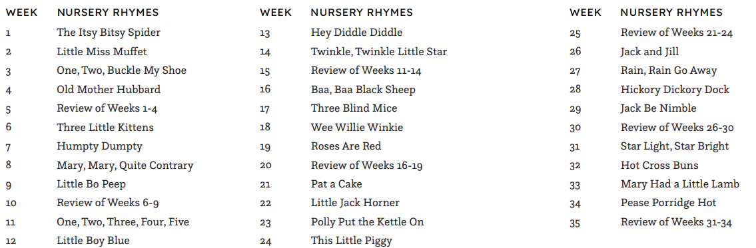

Multigrade Plan if necesssary

Junior Infants *Multigrade Year 1 | Senior Infants  *Multigrade Year 2
- Jack and Jill  - Little Miss Muffet  - Little Bo Peep  - 1,2 Buckle my Shoe  - Humpty Dumpty  - Twinkle twinkle  - Two little dickie birds  - 5 Little Pumpkins  - Row, row, row your boat  - Incy, wincy spider  - Five little ducks  - I’m a little teapot  - Baa baa black sheep  - Mary had a little lamb  - Hickory dickory dock  - Miss polly  - Little boy blue  - Hey diddle diddle  - Rock a bye-baby  - Mix a pancake  - The man in the moon  - Old King Cole  - There was a crooked man  - Mary, Mary quite contrary  - Polly put the kettle on  - Pussy cat, pussy cat  - One, two, three, four, five  - London bridge  - Ring a ring a roses  - One potato | Revision of Junior Infant rhymes  - The Ants go Marching  - ABCDE School is where I want to be  - See Saw margery daw  - Little Jack Horner  - Sing a song of sixpence  - Wind the bobbin up  - Sleeping Bunnies  - Sally go around the sun  - I had a little nut tree  - Pat-a-cake, pat-a-cake  - Twinkl Twinkl, chocolate bar  - Row row your boat crocodile  - Diddle, diddle, dumpling  - Jelly on a plate  - The grand old Duke of York  - Head, shoulders, knees and toes  - Little Tommy Tucker  - Frére Jacques  - Manners  - Pease Pudding Hot  - It’s raining it’s pouring  - Tiny Tim  - See Me Skip, See Me Run  - Pencil, rubber, whiteboard, glue  - The Listening Song  - Birthday Chant  - We’re going on a Bear Hunt

2. Reading
Learning Outcomes for Reading
● See Page 26 of the Primary Language Curriculum
Aims for Reading
In the area of reading development we aim to:
- promote positive attitudes and develop the appreciation of reading ● develop print awareness, an understanding of the purpose of print, and a control over the different ways meaning is derived from print.
- develop a range of reading skills and abilities that would include phonemic awareness, word identification strategies and a growing sight vocabulary
- develop an appropriate range of comprehension strategies to help interpret text beyond the literal level (prediction, inference, etc.)
- develop an awareness of the richness and diversity of reading material reading from a variety of texts of gradually increasing complexity
- engage in and enjoy sustained silent reading
- enhance emotional and imaginative development through reading
- develop cognitive ability and the capacity to clarify thinking through reading
- Use the school library to increase fluency and interest in books. .
Whole School Initiatives for Reading
  - Daily D.E.A.R. time
  - Paired/Buddy Reading
  - Study of Authors (Author of the Month)
  - Visiting Authors
  - Visits to Seán Lemass Library and close links with local librarians
  - Accelerated Reader
  - Reading Recovery
  - Audiobooks
  - Team Teaching/Station focus on Reading Skills
  - Literacy Lift Off/Power Hour Station Teaching
  - Guided reading Stations
  - Shared Reading with Parents
  - Book Fair in Term 3
Resources/Methodologies for Reading
● See each class level
Supplementary Resources for Reading
- Big Books
- Over the Moon
- Starlight
- BBOU recommended texts
- Picture books
- School Library
- Local Library
- Oxford Owls
- Poetry Scrapbooks
- Rhyme Books
- Story Books
- Fairy Tales
- Books of Myths and Legends
- Posters
- CDs/Interactive whiteboard resources
- Games
- Activities
- Springboard Levelled Readers
- PM levelled Readers
- Low Level High Interest Novels
- Sets of Novels e.g The Butterfly Lion, The Owl who was afraid of the Dark
School Library
The school library is well established. Books are sourced to reflect the interest of our school population and the wider world. School librarian links in with class teachers regularly. Prizes are awarded when children reach targets and a commemorative reading trophy is presented annually.

Rhymes/Poetry
Children in Infant classes will learn one Nursery Rhyme per week. Rhymes are used regularly during transition times throughout the day in English and Irish. See Nursery Rhyme Scheme (Infant level). Children from First to Sixth class will learn one poem per month by heart - See suggested Poetry Scheme at each class level from First to Sixth. Children are provided with regular opportunities to experience poetry and are encouraged to respond to it in different ways. Children are given opportunities from time to time to compose poetry after teacher modelling and immersion in the genre. Children are given the opportunity to display and read poetry. Poem/rhymes copies or scrapbooks are in use in classrooms. (See Poems per class level below)
Story
The children will explore the following types of story between Infants and Second class Fairy Tales, Fables, Myths and Legends. All classes will be exposed to picture books. They are a meaningful context for teaching sight-words, phonics, fluency, comprehension, concepts of print, phonological awareness and critical thinking. Novels will be used from Second to Sixth class and will be integrated with SESE where possible. See the Story Scheme at each class level.
Knowledge of the conventions of print
The child needs to understand that there are certain directional and positional conventions in print:
- a line of text is read from left to right
- the letters in a word are read from left to right
- text is read from top to bottom
- words are separated by spaces
- punctuation marks play a role in text.

Phonological Awareness
Phonological Awareness and Phonics is an integral part of the acquisition of the English language and a huge emphasis is placed on its importance in the early school years. Phonological Awareness is taught explicitly from Juniors to 1st Class using the Heggerty programme. ‘Bridge the Gap’ from the Heggerty programme is used for older pupils where deemed necessary. The skills mentioned below are used to enhance phonemic awareness.
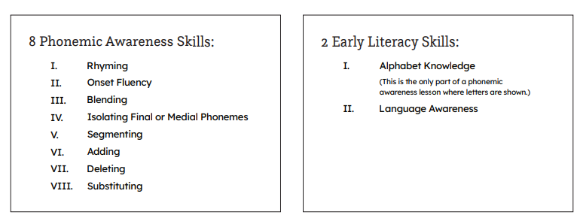

Phonological Awareness Methodologies:
In acquiring the ability to use sound/letter relationships (grapho/phonic cues)
the child needs to develop phonological and phonemic awareness, that is, an ability to manipulate the sound segments in words.
Activities such as the following can contribute to the development of this ability:
- saying and hearing nursery rhymes and rhymed stories eg Julia Donaldson, DrSeuss
- reproducing rhymes
- clapping and dancing to syllabic rhythms
- playing 'I spy' games involving onsets and rimes
- segmenting of sentences into individual words
- segmentation of words into syllables
- matching the length of a word to its utterance
The methodologies below are used by teachers to develop, reinforce and assess phonological awareness.
Infants teachers generally complete 3 days phonics lessons and 2 days Phonological Awareness.
However teachers intertwine and connect phonological awareness throughout lessons and transitions during the day e.g oral language games, 5 min brain breaks, shared reading activities, rhyme time etc
- Counting words in a spoken sentence
- Rhyme Recollection and Production
- Single syllable onset rime blending and segmenting
- Syllable blending and pronouncing
- Syllable segmenting and counting
- Phoneme Alliteration and discrimination
- Phoneme Isolation of initial sounds, final sounds and medial sounds
- Phoneme Blending and segmenting
- Phoneme Addition, Substitution and Deletion
* Revised where necessary from First to Fourth Class
https://heggerty.org/

Year 1 Junior Infants
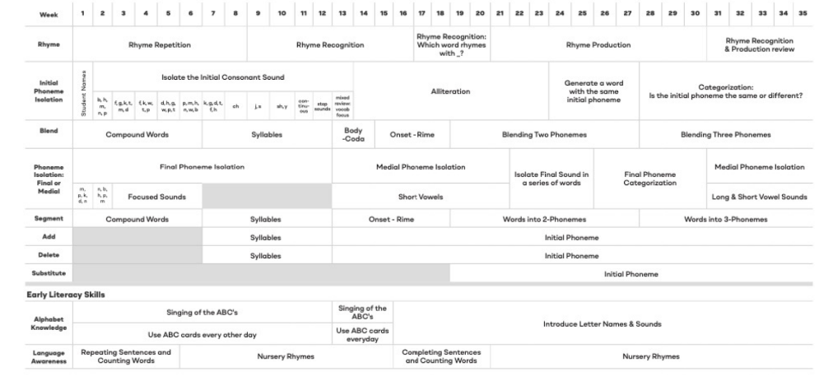
Year 2 Senior Infants
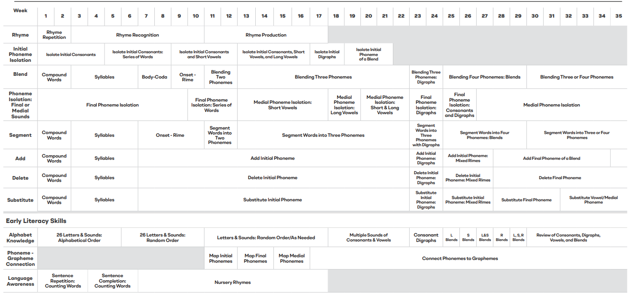

Year 3 1st Class
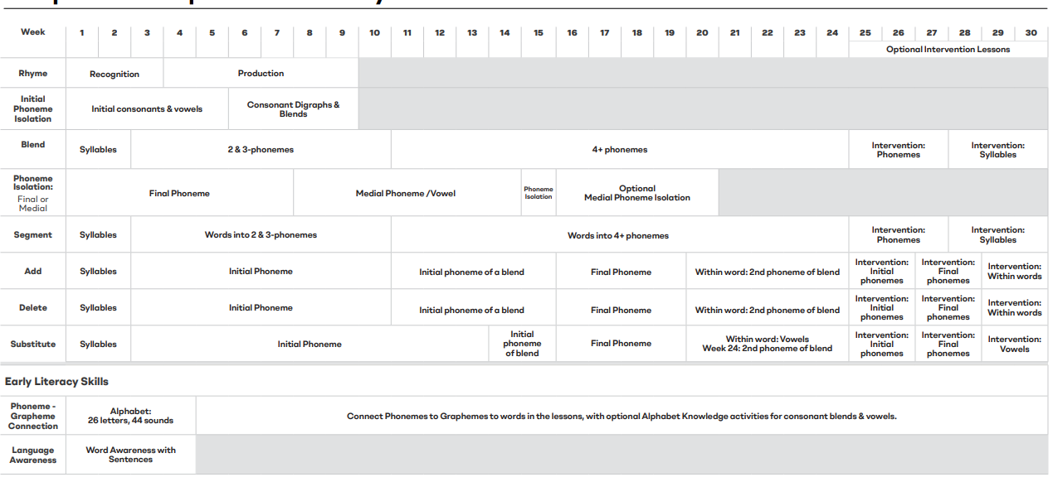Phonics
We have decided to use the UFLI scheme primarily to teach phonics.
Multi-sensory, phonetic, sequential Newell programme is in use with SET children. Flipcharts for each lesson are to be found on the UFLI Toolbox.
The lessons have been divided into class groupings however each teacher has access to the full scope of the programme therefore they will make their own professional judgement if the class are capable of moving on to further lessons. Likewise we are aware that some class groupings may complete less lessons than prescribed.
A corresponding phonics checklist is available in the literacy assessment folder to hand on to new class teacher and SET.
https://ufli.education.ufl.edu/foundations/toolbox/

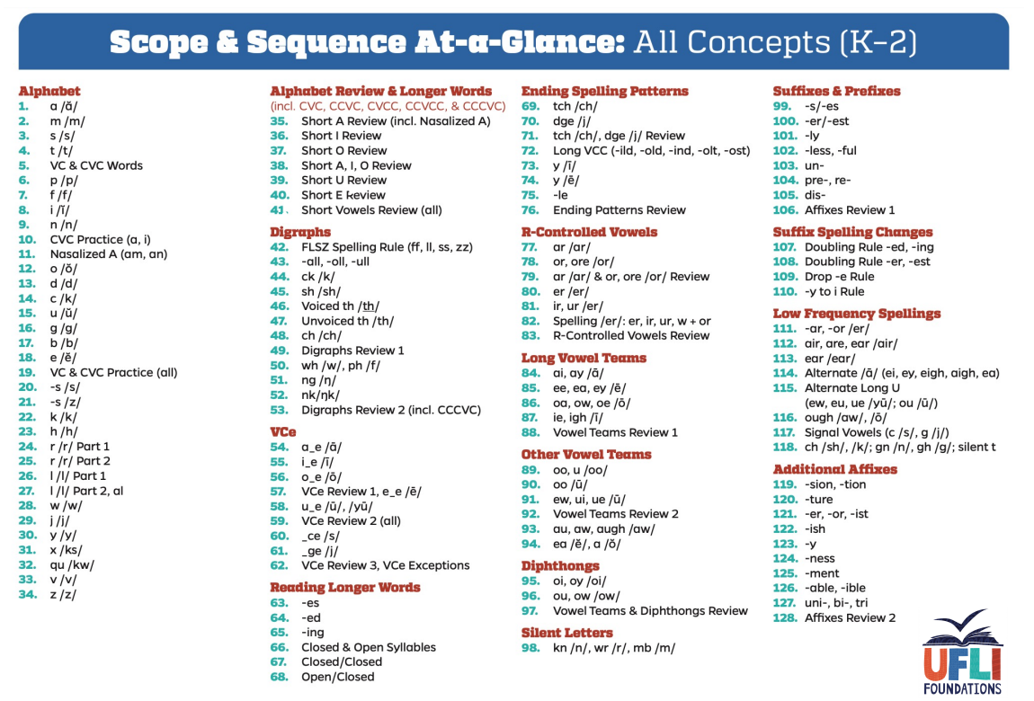

Alphabet
Reciting the alphabet will be taught in Junior and more on in Senior Infants. Children will be asked to say the alphabet starting and stopping at different intervals to promote familiarity. Children will be encouraged to state the name and the sound as well as a word together in Senior Infants. Alphabet Banners hung in each classroom with vowels in red and consonants in black. Staff are reminded to regularly discuss the different fonts/ letter formation we meet on a regular basis in books and online. eg gg , tt , aa, Ii I , L l
Sight Words
Basic sight vocabulary is an important element of the language base the child needs before beginning a structured reading programme. It will be acquired from a number of sources, such as ● language experience material ● large-format books ● environmental print ● labelling ● flash cards. Word Walls are evident in all classrooms. A multi-sensory approach is used to teach all sight words. The sight word is taught in isolation initially before being taught in context. Dictation will be used to assess knowledge of sight words.
Sight words are started in Junior Infants using Open sight word booklet. Booklets are often sent home for revision with parents
http://opensightwords.com/OpenSightWords2021.pdf
UFLI phonics programme encompasses heart words
https://docs.google.com/presentation/d/110-A-3aZH5AKcZAWHnpzx3i_hDHKAeZKATf5WCnWjL8/mobilepresent?mibextid=pwzuuw&slide=id.p
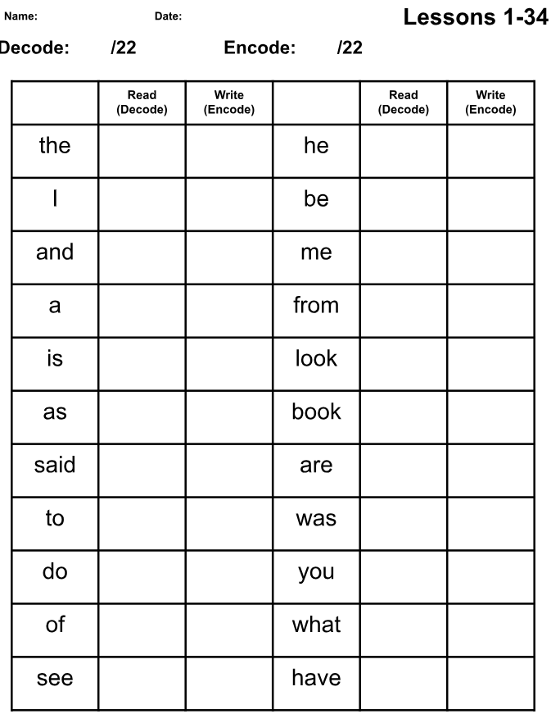

Corewords from Brendan Culligan are used for senior classes. Again with the emphasis on dictation. Children should be able to read and spell these words. Pretesting should take place at the start of the year and post testing throughout the year
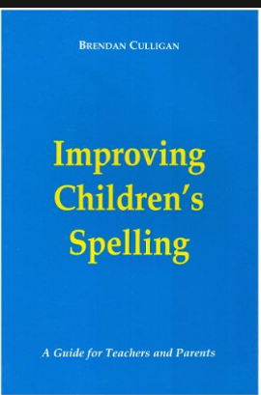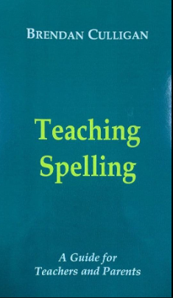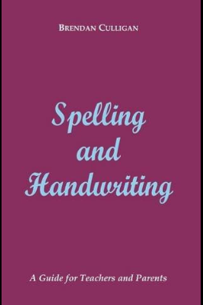
The SNIP programme 1,2, 3 is also used with special education teaching where necessary. SNIP contains high frequency words grouped by selecting those that visually look different to each other. SET team are using SNIP at lower level when necessary or they pre-teach sessions to allow for consolidation with peers.
Programme 1
http://www.snip-newsletter.co.uk/pdfs/downloads/literacy_programme_1.pdf
Programme 2
http://www.snip-newsletter.co.uk/pdfs/downloads/literacy_programme_part_2.pdf
Programme 3
http://www.snip-newsletter.co.uk/pdfs/downloads/literacy_programme_part_3.pdf

Assessment
Regular assessment takes place termly and during pre/post testing for Literacy stations or 6wk block. SNIP and B.Culligan’s Corewords also can be assessed on a regular basis using dictation.
We in St. Senan’s endeavor to support the reading process with sets of 5/6 real books which will enable the children to enjoy children’s literature in reading groups. Emphasis is placed on comprehension and not pushing children through levels. Pupils are encouraged to read non-fiction as well as fictional titles.

Reading Comprehension
Comprehension Strategies are taught using the Building Bridges of Understanding Programme
All Comprehension Strategies highlighted in yellow are new to this class level. All other Comprehension strategies have been taught previously
Introducing strategy
Using strategy

*denotes that the book is used to teach multiple strategies over the course of the year.
 | Comprehension Strategy | Suggested Text Books
Junior Infants  Senior Infants | Predicting | -Dear Zoo  -Peepo  -The Tiger Who Came to Tea  -Tiddler
 | Visualising | -We’re going on a bear hunt  -Where the Wild Things are
 | Connecting | -Five Minutes Peace  -The Rainbow Fish  -Can’t you sleep little bear?
First Class  And Second Class | Predicting | -Piper  -The Lamb who came for Dinner  -Gentle Giant  -Killer Gorilla
 | Visualising | -Ratty Tatty  -Grandfather Twilight  Bat Loves the Night  -Snow Day  -Dragon Post
 | Connecting | -Emma’s Lamb  -Camille & the Sunflowers  - Grandad’s Island  - Meerkat Mail
 | Questioning | -Lost & Found  -Alexander & the terrible, horrible, no good, very bad day  -Amelia’s Road

Third Class and Fourth Class  (listed books used in  conjunction with class  novels/read alouds) | Predicting | -The Mozart Question *
 | Visualising | -The Morning I met a Whale -Something Beautiful*
 | Connecting | -Henry’s Freedom Box*  -Something Beautiful*
 | Questioning | -The Lotus Seed*  -The Mozart Question *
 | Clarifying | -Amazing Grace
 | Synthesising | -Star of Fear, Star of Hope* -Henry’s Freedom Box
Fifth Class and Sixth Class | Predicting | -A Bad Case of the Stripes*
 | Visualising | -A Bad Case of the Stripes*
 | Connecting | -The Tunnel*
 | Questioning | -The Tunnel*
 | Clarifying | -A Bad Case of the Stripes*
 | Synthesising | Fables
 | Inferring | -The Tunnel*
 | Determining Importance | -Helen Keller

*BBOU picture books are centrally stored in SET room.
* Hang signals to go along with each strategy
*Visuals hung in each room to remind the children

Declunking

Declunking is the ninth strategy in use. Teaching this strategy is ongoing throughout the school.
When good readers read a text, they often come across a word that they find difficult to pronounce or decode. This difficult word is referred to as a ‘clunk’. When a reader meets a ‘clunk’, they have to ‘declunk’ it so that it makes sense. This Comprehension strategy involves providing pupils with explicit instruction on what to do when they meet a ‘clunk’.

Declunking/Reading Strategies Juniors - 2nd Class

Visuals hung in each classroom from Juniors to 2nd Class and in SET rooms

Focus on one strategy a month, however all strategies are on-going as pupils need to have a wide range of strategies in their toolbox.

Eagle Eye  Look at the pictures | Lips the Fish  Get your lips ready initial sound | Stretchy Snake  Stretch out the word like an elastic band
Trying Lion  Try it again | Chunky Monkey  Look for a chunk in the word | Skippy Frog  Skip the word and come back to it
Flippy Dolphin  Flip the vowel sound short/long | Revision off all Strategies

Reading Strategies 3rd -6th
Focus on one strategy a month

Revision of declunking strategies |  | Re-reading/Re-running
Skimming | Scanning | Comparing
Summarising and paraphrasing | Using Analogy | Consulting a Reference

Fluency
Draw attention to the following regularly to improve reading fluency and comprehension
Juniors - 6th

pace | tone | expression | self correction | awareness of punctuation

Reading schemes for all classes
The school has invested in a variety of reading schemes for use in both team-teaching and for homework. Pupils read a variety of both fiction and non fiction texts all catering for the differing abilities of our class groupings.

Decodable Wonderland and Dandelion phonic readers
These readers will be used in Junior Infants and Senior Infants as the pupils begin blending sounds they know. Decodable passages available online for each UFLI lesson.

Oxford Reading Tree + Songbird Readers
The Oxford Reading Tree readers will be used for team teaching in Senior Infants. They may also be used for differentiation in team-teaching in first and second class. Oxford Owls is also in use on the ipads

Springboard Readers
Levelled readers are for use in team-teaching. All pupils are tested for their starting level on the readers. This reading scheme will be used from Senior Infants upwards starting from level 1 up to level 30

Over the Moon programme is in use to support the language curriculum in the senior side of the school. In multigrade situation we will alternate between Over the Moon and the Starlight programme.

Readers
Levelled pm readers 1-30 are available for general use. A separate set of PM readers in use for the Reading Recovery Programme, levels 1 to 24 along with a set of alphabet books.

Authors of the Month
Used by teachers over the past number of years to help expose children to various authors and their work. This helps to motivate and engage them in reading for pleasure.
Biography of various authors are studied when introducing them to the class.

Infants | Julia Donaldson  Martin Waddell  Dr Seuss  Craig Smith  Eric Carle  Michael Rosen
First + Second | Roald Dahl  Anne Fine  Michael Morpurgo  Jill Tomlinson  Enid Blyton  Eoin Colfer
Third + Fourth | David Walliams  Dick King Smith  Michael Morpurgo  Jacqueline Wilson  Judy Blume  Jeremy Strong  Nick Sharatt  Tom Gates
5th + 6th | JK Rowling  Roddy Doyle  C.S. Lewis  Jane Mitchell  Shel Silverstein  Terry Pratchett  Onjali Q. Rauf

Writing

Learning Outcomes for Writing
- See Page 30 of the Primary Language Curriculum

Aims for Writing
In the area of writing development, we aim to:
- develop competent and confident writers in all First Steps writing genres
- develop print awareness and an understanding of the purpose and conventions of print
- promote a growing sight vocabulary
- utilise the various comprehension strategies
- write for different purposes and different audiences
- learn to edit and refine writing and develop a sense of appropriate presentation
- develop a personal style of writing and learn to distinguish and use appropriate levels of formality
- share writing experiences with others
- use computer technology in learning to write

Resources for Writing
See each class level

Writing Skills: First Steps Writing
Junior/Senior Infants
Term | Writing Genres  Junior Senior
Term 1 | - Recount | - Recount
Term 2 | - Recount  - Procedure | - Recount  - Procedure
Term 3 | - Recount | - Recount  - informal introduction to narrative

First/Second Classes
Term | Writing Genres  First Second
Term 1 | - Recount  - Procedure  - Narrative (Expose) | - Recount  - Procedure  - Narrative (Expose)
Term 2 | - Recount  - Narrative (Teach)  - Report | - Recount  - Narrative (Teach)  - Report
Term 3 | - Recount  - Report | - Recount  - Report

*Writing for socialisation will be visited in all classes each term.

Third/Fourth Classes
Term | Writing Genres  Third Fourth
Term 1 | - Recount  - Narrative | - Recount  - Narrative
Term 2 | - Report  - Procedure | - Report  - Procedure
Term 3 | - Persuasive (one sided)  - Explanation | - Persuasive(Opinion)  - Explanation

Fifth/Sixth Classes
Term | Writing Genres  Fifth Sixth
Term 1 | - Narrative  - Recount | - Narrative  - Recount
Term 2 | - Report  - Explanation  - Procedure | - Report  - Explanation  - Procedure
Term 3 | - Exposition  - Persuasive  - (One-Sided) | - Exposition  - Persuasive  - (Two-Sided)

Introduction of a new genre:

The formal teaching of one individual genre will take place over 6-8 weeks during each term, while the genres taught in the previous year will be recapped and revised.
The suggested structure for teaching a new genre is:
Week 1:
Familiarisation – showing the children lots of examples of this genre
Discovery (direct model) – engaging in focussed talk and discussion, questioning, etc.
Teacher models (teacher writes their own sample of that genre using their own ideas, not the children’s)

Week 2:
Familiarisation
Discovery (analysing text) - breaking down the text into its various subheadings, etc.
Teacher models – highlighting the structure, the language features, grammar and so on.

Week 3:
Modelled writing
Shared writing – teacher writes the children’s ideas

Week 4:
Modelled writing
Guided writing - using frameworks devised by teacher or the resource book

Week 5:
Modelled writing
Independent construction

Week 6:
Modelled writing
Independent construction
Presentation to audience (reading it for different classes, hall display, school website, class book, parish newsletter, competition entry, bringing it home, etc)
Week 7:
Independent construction
Presentation to audience

Poetry
Teachers and pupils have their own individual tastes in poetry. It is important that there is some flexibility in the selection of poetry by an individual class. The following guidelines are a support to class teachers in the teaching of poetry.

- It is important that children have the opportunity to hear, read, write and enjoy poetry on a regular basis.
- when writing poetry, allow the children to work as a whole class, in groups and pairs as well as individually.
- model writing the different types of poems.
- give children plenty of opportunity to see and discuss the style of poem you have selected before writing it themselves. Photocopy and laminate poems and have them in your room.
- give children the opportunity to present their work.

Infants | onomatopoeia poems  pyramid poems
1st & 2nd | acrostics  rhyming poems  alphabet poems  group poems  free poems  colour poems
3rd & 4th | adjective poems  up and down poems  sausage poems  riddle poems  character poems  limericks
5th & 6th | kennings  alliteration poems  cinquains  diamante poems  haiku

*There is a large selection of poetry anthologies throughout the school and the teachers make excellent use of IT to source poetry suitable for specific lessons and themes.

Spelling
We recognise that, as a whole school, a multi-dimensional approach to spelling is essential. Every class has varying levels of spelling ability and the pupils are assessed with work differentiated where necessary. Some children struggle to move from the phonetic spelling. Therefore children begin dictating spellings and sentences in Juniors and Senior Infants

Objectives for Spelling
Equip all pupils with strong phonological awareness skills incorporating awareness of syllables, rhyme and phonemes in words
- Spelling must be taught
- Spelling must be fun
- Realisation that not all spelling is phonetically based
- Spelling activities should be written
- Spelling strategies are taught to all children especially those who experience difficulty
- Self-checking is continuously encouraged to foster a more independent approach
- Spelling must never be a barrier to children’s writing as it is vital not to dampen a child’s enthusiasm to write by always insisting on accurate spelling
- Children are encouraged to take risks and attempt unknown words
- Children begin spelling informally in Senior Infants through exposure to phonics. Formalised spelling is introduced in First Class and continues throughout the remainder of the pupils’ years in the school.

Source of Spellings
- Heart words UFLI
- Brendan Culligan’s Corewords 1,2 & 3
- Phonics Scheme - UFLI
- New vocabulary
- Extension Work: Themed Spelling
- Dictionary
- SNIP
- Spellings Made Easy
- Word study activities

Our Approach to the Teaching and Learning of Spelling
- As spelling is visual, learning to spell cannot follow a completely phonics-based programme. The pattern in words must be visual so that words that look alike are grouped together although they may not sound alike. e.g. caught, daughter, taught
- Our focus is on letter patterns instead of just learning mat/hat, but/cut, we focus on ‘at’ patterns (letter strings), and therefore include ate, what, etc. It is important that we teach words which look the same irrespective of their sound,
e.g. come, some, women…
- Children are taught to look at words, see words within words and compare letter strings regardless of sound
- Spelling is taught with emphasis on the type of spelling errors rather than the number of errors
- The use of mnemonics and other strategies are encouraged to help children who struggle with spelling
- Look, Say, Cover, Write, Check Methodology (Look, Write & Check are all visual which emphasises the importance to spelling being a visual endeavour)
- Using Sound Letter Relationships
- Using Pattern
- Continuation from class to class
- Linking with onset and rime
- Print Rich Environment (ensuring balance between cursive displays and print display
- Children from 1st -6th have a hardback spelling copy which they bring with them from class to class. Each month they learn a new spelling rule which is taught explicitly to the whole class

Assessing Spelling
The children are encouraged to improve their spelling in their writing. Children’s spellings are assessed at the beginning of the year using the LETRs screener with the help of the SET team. This screener identifies patterns that children know or that they need support with. The class teachers can then plan for a block of week to target these particular areas. They are then re-assessed when they have completed the relevant block of work . Corewords and heartwords are studied regularly to ensure they are mastered and this work is often sent home as part of homework tasks.This ensures children are building their bank of spelling words and avoiding short-term rote learning. The ‘Friday test’ no longer exists but rather Dictation tasks allow for regular practise of their learning words.

Correcting Spelling in Writing Tasks
- Teachers will correct the spelling/dictation tasks and return them to the children.
- Teachers are encouraged to avoid marking every spelling wrong

Spelling and SET
Arrangements may be made under the direction of the class teacher. SET may support in class
with parallel teaching or station teaching. They may also withdraw an individual or group if a particular area needs to be targeted.

Parental Involvement and Spelling
Parents are encouraged to ensure that their children learn their heart or core words if they are part of their homework.

Grammar & Punctuation
- Each class grouping revises previous class list
Juniors/Senior Infants  *informally in Juniors |  | 1st and 2nd |  | 3rd and 4th |  | 5th and 6th
Syllables |  | Revision of Infants + |  | Singular and plural nouns |  | Gender
Consonants |  | Homonyms |  | Collective nouns |  | Similes
Vowels |  | Antonyms |  | Contractions |  | Proverbs
a + an |  | Synonyms |  | Prefix |  | Figures of Speech
Basic plurals |  | Connectives |  | Suffix |  | Metaphors
Capitals |  | Prepositions |  | Comparison of Adjectives |  | Abstract and concrete  nouns/ adjectives
Full stops |  | Pronouns |  | Naming all the parts of speech |  | Direct and indirect Speech
Question mark |  | Apostrophe possession |  | Irregular verbs |  | All parts of speech
Exclamation mark |  | Compound words |  | Quotation marks |  | Clauses
Comma |  | Proper Nouns |  | Apostrophe |  | superlative
Speech marks |  | Comma |  | Adverb |  | comparative
Opposites |  | Speech marks
Tense: present/past |  | plurals
Nouns |  | subject/ object of a sentence
Verbs |  | Suffix ed
Adjectives |  | Suffix ing
Alphabetical Order
Sentence starters
Sentence structures

Handwriting/Penmanship

See school Handwriting policy

Creative Writing
Children begin Creative Writing informally in the infant classes. This is stimulated and developed in many ways such as through Aistear and through the use of free drawing (Infant Classes) and free writing copies. Creative Writing is introduced formally in
First Class and continues throughout the remainder of the children’s years in the
school.

Selecting Topics for Creative Writing
Sources of topics for children’s writing include:
- Print-Rich Environment
- First Steps Writing- Narrative Genre
- Thematic Approach
- Personal Concerns
- Life at home and in school
- Stories
- Social Needs
- Personal Reading
- Poetry
- Drama
- Aistear
- Everyday personal experiences
- Use of home language

Strategies for Planning Creative Writing
- First Steps Writing- Narrative Genre strategies and ideas
- Oral Discussion: Whole Class, Teacher/Pupil, Pupil/Pupil
- Brainstorming
- Webbing
- Story Board
- Story Plans
- Story Templates
- Poetry/Drama/Story as stimulus

Whole School Approaches to Writing and Drafting
- Planning, Drafting, Editing, Re-drafting Method through the medium of First Steps from First Class
- Encouraging Self Correction and Self Checking

Correcting Creative Writing
For incorrect grammar, punctuation and spelling the teacher places a dot under the mistake and the children correct it. Constructive comments are used by teachers when correcting the children’s work.

Whole School Approaches to Valuing Creative Writing
- Displays
- Writer’s Corner
- Newsletter
- Constructive and precise comments when possible
- Work included in anthologies
- Team Teaching with a focus on the Narrative Genre for creative writing

Assessment and Record Keeping

  - Standardised testing:
-Drumcondra Test of Early Literacy
-Drumcondra Reading Tests
-Drumcondra Spelling Tests
-YARC (Senior Classes)
-NRIT 2nd and 4th? and with SET pupils
  - Teachers will hear children reading formally at least once a week.
  - LETRS spelling screener
  - Schonell Reading and spelling tests
  - Word Spree
  - Sight Word Checklists
  - UFLI assessments
  - AR star testing and pupil profile
  - Reading Recovery assessments
  - Running Records
  - PSAK (EAL pupils)
  - Diagnostic tests
-Dyslexia Early Screening Test and Dyslexia Screening Test
-British Picture Vocabulary Scale
-Belfield Infant Assessment Profile
-Neale Analysis of Reading Ability
  - CAT with SET children
  - CAT4 with 1st Class annually
  - Station teaching pre and post testing is also completed with each class level.
  - Teacher checklists
  - Rubrics PDST booklets
  - Teacher observation
  - Teacher designed tasks
  - Work samples
  - Portfolios
  - Projects
  - ICT - Kahoot and SeeSaw

- Account with GL Assessments to purchase necessary assessments pertaining to particular pupil’’s needs

Children with Different Needs
English activities will be differentiated in order to meet the needs of the children in a particular class. Children with special educational needs will receive support from our Special Education Teachers. We promote an active learning environment, with children working in groups at their level, where the class teacher is responsible for the learning in the classroom and is assisted by the SET team. Team teaching and Station teaching blocks are arranged throughout the year.

Where a teacher recognises that a child displays a particular ability in English, this will be communicated to the parents early on in the year, so that the child may have the opportunity to take out of school lessons, circumstances permitting. We as a staff promote early intervention and try to use both in class and withdrawal throughout the year as a means of helping the children with literacy needs. Reading Recovery is an intervention used with children in Senior Infants to help achieve at word, sentence and text level. Teachers will encourage such children to read and write for their classmates, so that the other children will have opportunities to listen and respond.

E.A.L. Provision

There is a small percentage of children in St.Senans for whom English is an Additional Language. Their proficiency in English is tested biannually (December and May/June) using the PSAK assessments or Up and Away English Proficiency Benchmarking. Up and Away Resource book is helpful for Class and SET teachers to guide language learning. My First English book from the IILT is also an engaging resource for EAL pupils. SET teachers work in a withdrawal and in-class support capacity, dependent on the needs of individual classes.
Resources
- https://ncca.ie/media/2172/primary-school-assessment-kit.pdf
- https://ncca.ie/media/2472/up_and_away.pdf
- https://ncca.ie/media/2077/first_englishbook.pdf

Equality of Participation and Access
In St.Senan’s school equal opportunities will be given to all children regardless of gender, ethnic background and socio-economic status across all strands and activities.

Homework
Teachers can assign English homework at their discretion in accordance with the guidelines of the homework policy and the Department of Education. As a core subject, English homework should be assigned daily. Parents/carers are regularly reminded of the importance of oral language and reading homework, as well as written work.

Organisational Planning
The teaching of English will be conducted in line with the new time allocations as set out by the DES and NCCA as follows:

Class Level: | Time Allocation for Language 1 (i.e. English):
Junior and Senior Infants | 4 hours per week
First – Sixth Class | 5 hours per week
Discretionary time may also be used for the teaching and learning of English

The teaching of English will be organised on both a whole-class and team-teaching level. A team teaching approach will be taken to support the teaching and learning of English and will involve the input of the support staff in the classroom. Such will be organised based on the needs of each class and will focus on specific areas of the curriculum.
Timetables are organised to ensure that classes receive a 6-week block of literacy stations, guided reading or guided writing. Time is allowed on either side of this for pre and post assessments to take place.

Resources and ICT
As a new developing school, we endeavour to build on and develop the resources available for teaching and learning as the school grows. Teachers will be encouraged to maximise resources available to them. The school will ensure that teachers’ resources for school-wide programmes will be available to all teachers, including Jolly Phonics, First Steps, Building Bridges of Understanding, PM+, Oxford Reading Tree and English as an Additional Language programmes.

ICT will be used in classroom and support settings to further support the teaching and learning of English in the form of Interactive Whiteboards, iPads, online programmes etc.

An appropriate amount of money may be requested from the Board of Management to fund our English programme. Parents may be requested to make a very small contribution should we find a shortfall in finances. Contributions may also be requested from the Parents Teacher Association, through fundraising events and sponsorship from local businesses.

Individual Teachers Planning and Reporting
Class Teachers’ Planning:
Individual teachers will plan their yearly English programme specifically for their own class, while at the same time ensuring that their plan coordinates with and is reflective of this overall school plan. This should ensure clear progression as children move from class to class. Teachers at each class level will collaborate on content and methodology for English from this whole school plan and it will be monitored and assessed on an on- going basis.

Teachers are expected to complete yearly (or termly) plans for the teaching of English in their classes and are responsible for the implementation of such. Learning outcomes directly from the Primary Language Curriculum are included in each teachers’ long term scheme. They must also include English in their fortnightly (or weekly) plan. Such must include specific objectives, learning content and key vocabulary.

The Cúntas Míosúil must document what has been covered in the teaching and learning of English each month

Support Teachers’ Planning:
Teachers must complete fortnightly plans detailing the teaching of English to such pupils. Teaching of English for pupils with special educational needs will also be documented in the planning documents of S.E.T. staff.

Staff development
Staff needs will be assessed and the local Education Centre will be requested to provide suitable ongoing training as the need arises. The staff will also avail of training as provided by the Department of Education and Skills, particularly in relation to further training days for the implementation of the Primary Language Curriculum. The school is engaging in sustained support from the PDST with regards to Literacy. SET teacher training in Reading Recovery is also ongoing.

Parental Involvement/Community Links
Parents/carers have a crucial role to play in their children’s language development. Talking to adults, hearing them talk, hearing stories read and told and being encouraged to read all have an influence on children’s language development that supports and complements the school experience. Parents are informed of this at the beginning of the year at each class meeting.

Success Criteria
Means of assessing this plan are as follows
Teacher/parent/pupil/community feedback
- Children’s feedback regarding their learning
- Suggestions and reports of DES Inspectorate
- Monthly records of teaching and learning
The success of this plan will be measured by teacher observation of pupil enjoyment and participation in oral language, reading and writing activities. The success of the plan will also be measured by the achievement of pupils in standardised tests. Feedback and reflection will be used as an informal method of measuring the success of this whole- school plan.

Implementation and Review
- Roles and Responsibilities
The plan will be implemented by all members of the teaching staff. The principal will play a role in overseeing its implementation.

- Timeframe
This plan will be reviewed in Term 1 2024

Ratification and Communication
The attention of all newly appointed staff will be drawn to this whole-school English plan upon their appointment to the school by the Literacy post holder. This policy will be published on the school website, upon its development, and a copy of it will be provided to the Parent Teacher Association, when established. A copy of this policy will be made available to the Department of Education and Skills and the Patron, if requested. Hard copies of this, and all school policies, are available at the school upon request.

Signed: (Chairperson, BOM)

Signed:
Date: 29th August 2023
Date of next review: Term 1 2024/25

Appendix 1 List of Stories/Poems by Class grouping
Story (Oral Language and Reading)

Junior Infants  Year 1 | Senior Infants  Year 2
Independent Reading  - Decodables  - PM/Springboard levelled readers  Suggested Picture Books:  - The Kissing Hand  - Goat Goes to Playgroup  - The Smartest Giant in Town  - The Pig in the Pond  - Handa’s Surprise  - Peace at Last  - Owl Babies  - Rumble in the Jungle  - The Very Hungry Caterpillar  - Rosie’s Walk  - Elmer  - Farmer Duck  - Each Peach Pear Plum  - The Enormous Turnip (integrated with Gaeilge)  - Dear Zoo (Building Bridges)  - Peepo (Building Bridges)  - We’re Going on a Bear Hunt  (Building Bridges)  - Five Minutes Peace (Building Bridges)  - The Rainbow Fish (Building Bridges)  Fairytales:  - The Three Little Pigs (integrated with Gaeilge)  - The Gingerbread man (integrated with Gaeilge)  - Goldilocks and the Three Bears (integrated with Gaeilge) | Independent Reading  - Decodables  - PM/Springboard levelled readers  Suggested Picture Books:  - The Gruffalo  - The Snail and the Whale  - The Scarecrow’s Wedding  - Elmer and the Rainbow  - Elmer’s Special Day  - Where oh where is Rosie’s  chick?  - Dear Mr Blueberry  - Dear Greenpeace  - The Day the Crayons Quit  - The Day the Crayons Came Home  - Lilly’s Purple Plastic Purse (Building Bridges)  - Think of an Eel  - The Tiger who Came To Tea (Building Bridges)  - Tiddler (Building Bridges)  - Where the Wild Things Are (Building Bridges)  - Can’t You Sleep Little Bear?  (Building Bridges)  - Zoo (Building Bridges)  - Silly Billy (Building Bridges)  Fairytales:  - Little Red Riding Hood (integrated with Gaeilge)  - Cinderella (integrated with Gaeilge)  - Jack and the Beanstalk (integrated with Gaeilge)  - Hansel and Gretel (integrated with Gaeilge)

Poetry (Oral Language)

First and Second Class
Year 1 | Year 2
Each class teacher can choose poems from this list but the list is not compulsory or exhaustive and class teachers are encouraged to select poems
from other sources if they so wish.
Writing Poetry  - Alphabet poems  - Acrostic poems  - Colour Poems  Selection of rhymes/poetry  - ‘Seasons’ by Kerri Ward  - Homework, I love you by Kenn Nesbitt  - ‘My Brilliant Friend’ by Roger  McGough  - ‘Charlotte’s Dog’ by Kit Wright  - ‘Eletelephony’ by Laura  Elizabeth Richards  - ‘Eight Tentacles’ by Julia  Donaldson  - ‘Battling Fire’ by Mary E. Cronin  - ‘Fireworks’ by Gareth  Lancaster  - ‘The Worm’ by Robert  Bergengren  - ‘Ben’ by Collin West  - ‘A Spike of Green’ by Barbara  Baker  - ‘The Spaghetti Challenge’ by  Leslie D. Perkins  - ‘The Friendly Cinnamon Bun’ by  Russell Hoban  - ‘Camping’ by Karen McGuigan Brothers  - ‘Sunflakes’ by Frank Asch  Misc.  - Sing Sing Rhyme  - Way Down South Poem  - Old Mother Hubbard Rhyme  - Peter Piper Poem  - I saw a ship a sailing Rhyme  - Simple Simon Rhyme  - Baby and I Rhyme  - I had a Box of Crayons  - On the Ning nang Nong | Writing Poetry  - Rhyming Couplets  - Pyramid Poems  - Group Poems  Selection of poetry  - ‘Taking one for the team’ by  Sarah Holbrook  - ‘With a friend’ by Vivian  Goulad  - ‘The Sloth’ by Theodore  Roethke  - ‘The Crocodile’ by Lewis Carroll  - ‘If You Should Meet A Crocodile’ by Christine F  Fletcher  - ‘Sir’s a Secret Agent’ by Tony  Langham  - ‘I’m a Pirate Ballerina’ by Ken  Nesbitt  - ‘The Dragon’s Birthday Party’  by Ian McMillan  - ‘I Opened a Book’ by Julia  Donaldson  - ‘My Teacher took my iPad’ by  Ken Nesbitt  - ‘Globetrotting’ by Kerri Ward  - ‘Penguin’ by June Creddin  - ‘Greedy Dog’ by James Hurley  - ‘This is just to say’ by William  Carlos Williams  - ‘The Writer of this Poem’ by  Roger McGough  - ‘Auntie Betty thinks she’s Batgirl’ by Andrea Shavick  - County Poem  - Kenn Nesbitt Poetry

First and Second Class Story
Year 1 | Year 2
Novels available in School Library and Seán Lemass Library  - The Owl who was afraid of the dark  - The Magic Finger  - The Legend of Spud Murphy  - Ed’s Potty  - Conker  - My Father and the Dragon Trilogy  Picture books (Building Bridges)  - Chrysanthemum  - The Dot  - Wacky Wednesday  - Billy’s Bucket  - How to Catch a Mermaid  - ‘Twas the Night Before Christmas  - Santa comes to Clare  - Katie and the Water Lily Pond  - Michael Recycle  - The Runaway Pancake  - Samson’s Titanic Journey  - Lifecycle of a Butterfly  - Big Blue Whale (BBOU)  Myths, Legends and Fables  - The Salmon of Knowledge  - Fionn and the Giant  - The Boy who Cried Wolf  - St.Patrick/St.Senan  Fairytales  - Hans Christian Andersen  - Tomás na hÓrdóige as Gaeilge | Novels available in School Library and Seán Lemass Library  - The Cat who wanted to go Home  - The Legend of Captain Crow’s Teeth  - The Worst Boy in the World  - The Twits  - Fox Friend  - A collection of Leprechaun Stories by Bairbre McCarthy  Picture books (Building Bridges)  Myths, Legends and Fables  - King Labhra Loinsigh  - Tír na nÓg  - The Wooden Horse of Troy  - St.Brigid’s Cloak

Third & Fourth Class
Poetry (Oral Language)

3rd + 4th Class
Year 1 | Year 2
Each class teacher can choose poems from this list but the list is not compulsory or exhaustive and class teachers are encouraged to select poems
from other sources if they so wish.
Writing Poetry  - Limericks  - Shape/Sausage poems  - Up and Down poems  Selection of poetry  - ‘I like to go Camping’ by Ken  Nesbitt  - ‘The Witch’ by Percy H. IIot  - ‘Michael Built a Bicycle’ by  Jack Prelutsky  - ‘The Quarrel’ by Eleanor  Farjeon | Writing Poetry  - Character poems  - Riddle poems  - Adjective poems  Selection of poetry  - ‘Elephant’ by Alan Brownjohn  - ‘Computer Games’ by Lee  Dallow  - ‘The Can-Can’ by Mandy Coe  - ‘Dear Santa, Did You Get My Tweet?’ by Kenn Nesbitt

- ‘Message from a Mouse, Ascending in a Rocket’ by Patricia Hubbell  - ‘This year I will stay awake’ by  Paul Cookson  - ‘Bob’s Sled’ by Kenn Nesbitt  - ‘Boy’s Game’ by Eric Finney  - ‘Rapunzel, Rapunzel’ by Kenn  Nesbitt  - ‘A Dragon in the Classroom’ by  Charles Thomson  - ‘Be Glad Your Nose is on your Face’ By Jack Prelutsky  - ‘The Old Brown Horse’ by W. F.  Holmes  Misc  - ‘Egyptian Afterlife’ by Roger  Stevens  - ‘Elbow Grease’ by Elizabeth  Fleming  - ‘The Sound Collector’ by Roger  McGough  - ‘Limerick’ by Jack Ousbey  - Limericks by Edward Lear  - ‘What am I’ by Jo Peters  Selection of poems for poetry response  - ‘Electric Guitars’ by James Carter (Shape poem)  - ‘The Sound Collector’ by Roger  McGough | - ‘Your Dresses’ by Carol Ann  Duffy  - ‘Immigration Trap’ by John  Foster  - ‘The Wicked Stepmother’ by  Lindsay MacRae  - ‘The Day I Fell Down the Toilet’ by Steve Turner  - ‘Today is Very Boring’ by Jack Prelutsky  - ‘Give and Take’ by Roger  McGough  Selection of poems for poetry response  - ‘Teaser’ by Tony Mitton (The  Works - Riddle poem)  - ‘Riddle’ by John Cotton (The  Works)  - The Wind by Gareth Owens  - The Whisper-Whisper Man by Anonymous  - Weather by Eve Merriam/ Rain Poem by Elizabeth Coatsworth

Story (Reading)

3rd + 4th Class
Year 1 | Year 2
Novels available in School Library and Seán Lemass Library  - Tom Crean The Ice Man by Michael Smith  - The Butterfly Lion by Michael Morpurgo  Picture books (Building Bridges)  - The Mozart Question  - This Morning I met a Whale  - Something Beautiful  - Henry’s Freedom Box  - The Lotus Seed  - The Big Blue Whale  - Walk with a Wolf  - Gentle Giant  Myths, Legends and Fables  - The Cattle Raid of Cooley  - Tuatha Dé Danann  - Atalanta’s Race | Novels available in School Library and Seán Lemass Library  - Little Manfred by Michael Morpurgo  - The Boy in the Dress by David Walliams  Picture books (Building Bridges)  - When Jessie Came Across the Sea  - Her Mother’s Face  - Star of Fear, Star of Hope  - Grandma Elephant’s in charge  - Voices in the Park  - Henry’s Freedom Box  Myths, Legends and Fables  - The Children of Lír  - The Naming of Cúchulainn  - The Legend of Golem  - The Old Man and The Figs

Fifth & Sixth Class
Poetry (Oral Language)

5th + 6th Class
Year 1 | Year 2
Each class teacher can choose poems from this list but the list is not compulsory or exhaustive and class teachers are encouraged to select poems
from other sources if they so wish.
Writing Poetry  - Alliteration poems  - Kennings  - Free poems Selection of poetry Starlight  - ‘Empty House’ by Gareth Owen  - ‘Hunter Trials’ by John  Betjeman  - ‘The Hero of the Match’ by  Neil Adams  - ‘Thumbprint’ by Even Merriam  - ‘Little Tree’ by E.E Cummings  - ‘The Kwackagee’ by James  Reeves  - ‘From a Space Rocket’ by  Raymond Wilson  - ‘The All-Purpose Children’s Poem’ by Roger McGough  - ‘A Slash of Blue’ by Emily  Dickinson  - ‘What Is the Pond Doing?’ by  Diana Hendry  - ‘The Pool’ by Andrew Fusek  Peters  Selection of poems for poetry response  - Jabberwocky by Lewis Carroll (Starlight)  - A Dragon’s Lament by Jack  Prelusky | Writing Poetry  - Cinquains  - Diamante poems  - Haiku  Selection of poetry Starlight  - ‘The Toe Wrestler’ by Kerri  Ward  - ‘Mashed Potato Love Poem’ by  Sidney Hoddes  - ‘Colonel Fazackerley’ by  Charles Causley  - ‘A Martian Sends a Postcard  Home’ by Craig Raine  - ‘The Visitor’ by Ian Serraillier  - ‘The Magic Box’ by Kit Wright  - Extract from ‘The Rime of the Ancient Mariner’ by Samuel Taylor Coleridge  - ‘Flint’ by Christina Rossetti  - ‘In Flanders Fields’ by John  McCrae  - ‘Growing Up’ by Gareth Owen  - ‘The Road Not Taken’ by  Robert Frost  Selection of poems for poetry response  - Prince Kano by Edward Lowbury (Starlight)  - The Listeners by Walter De La  Mer

Story (Reading)

5th + 6th Class
Year 1 | Year 2
Novels available in School Library and Seán Lemass Library  - Kensuke's Kingdom  - Wildflower Girl  Picture books (Building Bridges)  - The Mozart Question  - This Morning I met a Whale  - Something Beautiful  - Henry’s Freedom Box  - The Lotus Seed  - The Big Blue Whale  - Walk with a Wolf  - Gentle Giant  - Voices in the Park  Myths, Legends and Fables  - Diarmuid + Gráinne  - Medusa  - The King with Donkey’s Ears  - The Frog Who Wished for a King | Novels available in School Library and Seán Lemass Library  - Holes  - Wonder  Picture books (Building Bridges)  - When Jessie Came Across the Sea  - Her Mother’s Face  - Malala's Magic Pencil  - The Boy Who Fell Off the Mayflower  - Newspaper Boy and Origami Girl!  - Grandfather’s Journey  - Star of Fear, Star of Hope  - Grandma Elephant’s in charge  - Henry’s Freedom Box  Myths, Legends and Fables  - Oisín in Tír na nÓg  - The Cattle Raid of Cooley  - The Golden Goose  - How the Moon became Beautiful

Novels
Novels are available from the Librarian. Groups of novels are available for stations or guided reading. Sets of Novels also available from Seán Lemass library. Teachers have library cards for their own class. There is a list of available books in the school library below:

